**Project Development phase**

**Project Development delivery of sprint 1**

|  |  |
| --- | --- |
| Team ID | PNT2022TMID50833 |
| Project name | Plasma donorapplication |

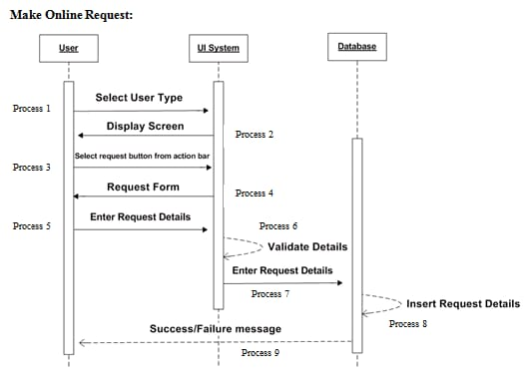

**Coding:**

<project xmlns="http://www.netbeans.org/ns/project/1">

<type>org.netbeans.modules.java.j2seproject</type>

<configuration>

<data xmlns="http://www.netbeans.org/ns/j2se-project/3">

<name>bloodbank</name>

<source-roots>

<root id="src.dir"/>

</source-roots>

<test-roots>

<root id="test.src.dir"/>

</test-roots>

</data>

</configuration>

</project>

**Software required:**

XML & Java

**System required:**

RAM-minimum 4gb processor-Min. Configuration OS-Windows/Linux/Mac